THUY LOI UNIVERSITY


SCIENTIFIC RESEARCH PROPOSAL
STUDY ON THE STABILITY OF HIGHWAY SLOPE USING GRAVITY RETAINING WALL

Members of research group:
Nguyễn Đức Nghĩa 58CNK
Nguyễn Sỹ Mạnh 58CNK
Tô Gia Lộc 58CNK
Nguyễn Văn Hưng 58CNK
Class: 58CNK
Faculty: School of International Education/ Civil Engineering
Instructor: PhD. Ngô Trí Thường

Table of Contents
Chapter I. Introduction. 3
1. Over view of the research 3
2. The purpose of the research. 3
3. Object, scope, and research method. 4
a) Research object. 4
b) Research scope 4
c) Research Methods 4
Chapter II. Overview of The gravity retaining wall. 4
1. Definition of gravity retaining walls. 4
2. Basic structure 6
3. Classification. 7
a) Classified by shape and texture 7
b) Classification according to height of wall. 8
c) Classification by material. 8
d) Common types of gravity retaining walls. 8
4. Drainage for embankment behind retaining wall. 9
5. Conditions in use of gravity retaining wall. 11
6. Scope of application. 11
Chapter III. Explanation of calculation 12
1. The background of calculation. 12
a) Group theoretical equilibrium limit of solid mass. 12
b) The group according to the limit elemental equilibrium theory (point). 13
2. Calculation and explanation 13
a) Determine Ecd 13
b) Determine the slip surface θ 15
c) Select the parameters 16
d) Soil mechanical properties of embankments 16
e) Vertical soil pressure due to embankment weight 17
f) Earth pressure is passive 17
g) Flip checking 17
h) Checking slip flat 18
3. Calculation for the retaining wall with different height 18
a) Calculation for several examples of gravity retaining wall. 18
b) Illustration of calculation examples. 18
Chapter IV: Conclusion and recomentation. 22
References 23

Chapter I. Introduction.
- Over view of the research.
- Along with the general development of the country's construction technology. Civil constructions, transport infrastructure, dikes, embankments, etc. These developments require the construction of retaining walls, embankments, slopes, etc.
- Currently, landslides often occur on roads with complicated geological structure and topography, especially in high mountains. There are several ways to avoid subsidence but a common method is to use retaining walls. Applied retaining wall types include: rip rap retaining wall, gabion wall, rubble stone wall, concrete wall, reinforced concrete wall, anchoring reinforced concrete wall, reinforced concrete beam wall. , Reinforced concrete arch, gravity wall.
- In recent years , the introduction of different types of retaining walls has provided us with more suitable options, in particular the gravity retaining walls which use their own gravity to resist the horizontal load caused by the ground, the natural embankment, the above load, ...
- In order to report reasonable conclusions, it is necessary to have computational studies on the concrete cases of concrete retaining walls.

The purpose of the research.
- In order to ensure the stability of the slope as well as the roads on many different terrains and solve the economic problem when installing and using gravity retaining walls, the study of "Study on the stability of highway slope using gravity retaining wall", is really necessary to provide a reasonable design for the parameters of the gravity retaining wall.

Object, scope, and research method.

Research object.
- Theoretical of gravity retaining wall
- The practical engineering of using the gravity retaining wall in protects the highway slope.
- Research scope.
- Theoretical, calculation and application of gravity retaining wall
- Project using gravity retaining walls.
- Research Methods.
- Researching theory, selecting documents and inheriting research results of related scientific topics and projects.
- Base on the calculation theoretical, propose the typical dimension for the gravity retaining wall with different height of slope.

Chapter II. Overview of the gravity retaining wall.

Definition of gravity retaining walls.
- The retaining wall, which depends on its own weight to stand alone, is called the retaining wall of gravity. This retaining wall is a massive. It use the self-weighted to against the force. When designing this type of retaining wall, sliding, bearing and overturning forces should be considered and tested.
- Retaining walls are works to keep the embankment slope or digging stable from slipping during work, when working with retaining walls in contact with the land behind the walls and under the effect of soil pressure.
- Gravity retaining walls are used to:
  - Keep the soil behind the wall balanced, without slipping or falling.
  - Avoid landslide happens in mountainous terrain.
  - Preventing landslides when building new projects beside old projects.
  - Anti-landslide for river banks and cliffs.
- Gravity retaining wall is one of development step in the construction field related to the construction of avoiding erosion embankments and slopes.
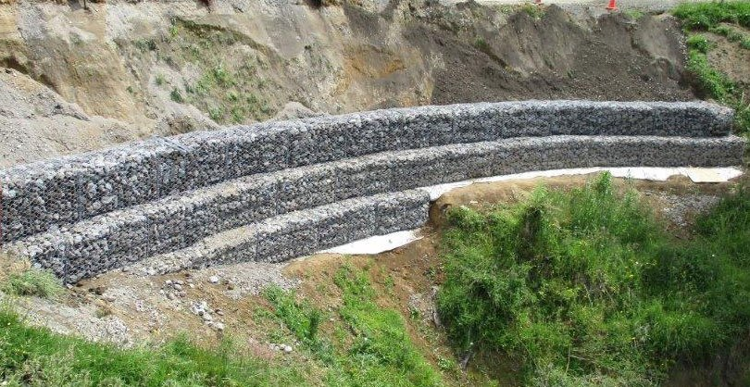
Figure 1. Gravity wall built by gabion (Source: Internet).
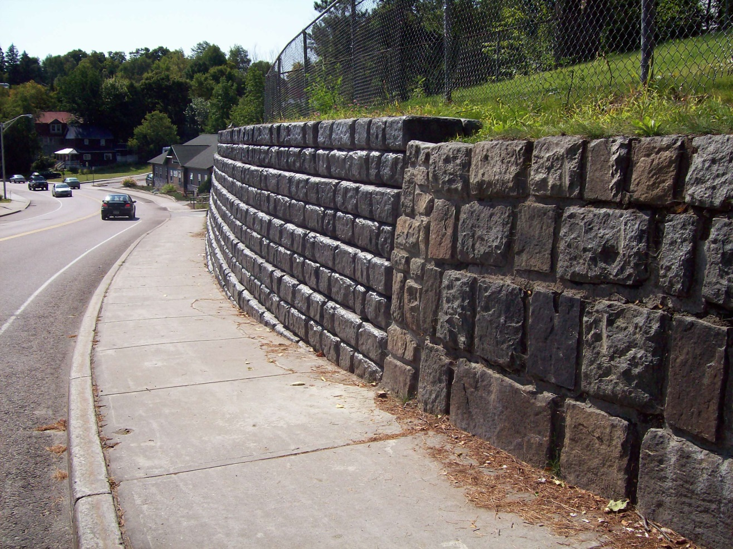
Figure 2. Redi-rock retaining gravity wall (Source: Internet).
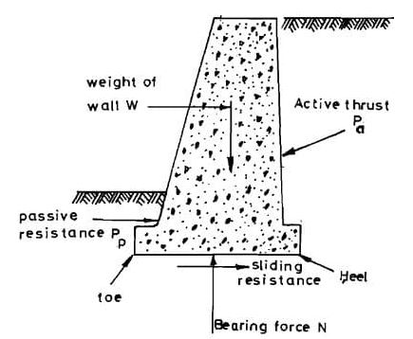
Figure 3. Loads acting on the retaining wall (Source: Internet).
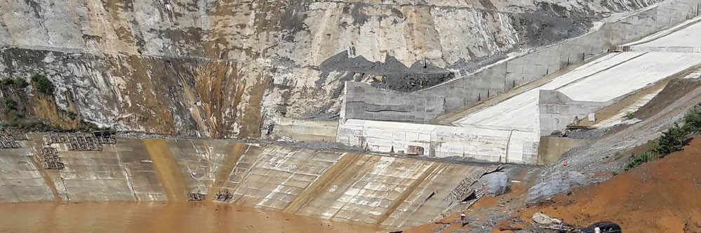
Figure 4. Gravity wall in hydropower projects (Source: Internet).
- Basic structure.
- Main parts of retaining walls include: Top wall, body wall, wall surface, foundation, back wall, bottom of foundation, inner wall foot, and outer wall foot. Walls can be made in straight lines or broken to suit the terrain conditions, geology and economic requirements.
- The back of the wall is inclined, the pressure on the soil is small, so the cross-section of the body is relatively economical, when used for the excavated foundation, the back of the wall and the slope will stick together, the amount of excavated foundation and backfilled soil is relatively small.
- The inclined wall type has a large impact on the soil, but when the width of the masonry is relatively steep, the vertical wall surface can be reduced to the height of the wall. If only the upper part of the back wall is sloped in, the back wall will be convex, thus reducing the size of the upper section of the wall (including the height) and often used as a retaining wall of the excavated foundation.

Classification.
- Classified by shape and texture.
- Classified by shape.
- Inclined walls (Figures 5a, b): are again classified into two types of forward tilt and backward tilt.
- Battered wall (Figure 5c): α angle of wall back is large.
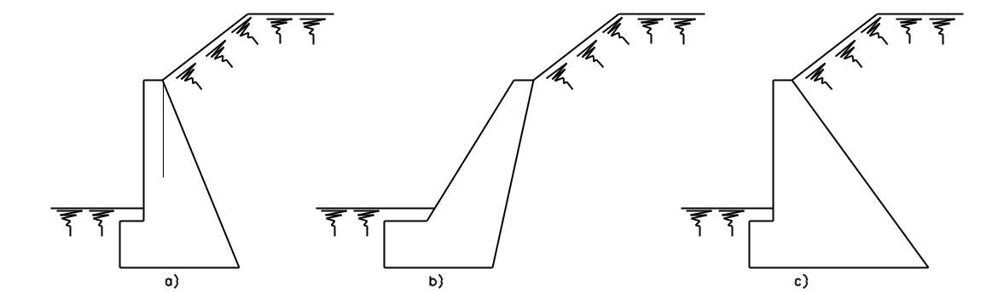
Figure 5. Classification of retaining walls.
- Classified by texture.
- Continuous wall: made by concrete, stones, bricks (Figure 6a).
- Precast wall (Figure 6b).
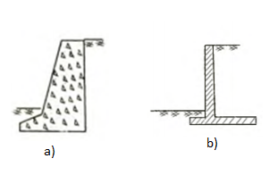
Figure 6. Classification of retaining walls.

Classification according to height of wall.
- Low walls are those with H = 5 m height.
- Average walls are those with H = 5 - 15 m height.
- A high wall is a wall with a height H > 15.

Classification by material.
- Concrete wall.
- Reinforced concrete wall.
- Cobble stone, cyclopean concrete, brick wall and masonry stone wall.

Common types of gravity retaining walls.

Classification | Advantages | Disadvantages | Noted
Geocell wall | - Fast building  - Material saving  - High stability  - Retaining walls protect slopes for civil and transport works | This method applies only to the slope (1: 2 to 1: 3), if the length of the slope is large, the stacking of sand sacks is extremely difficult. Sand sacks after finishing are also easy to slip. | 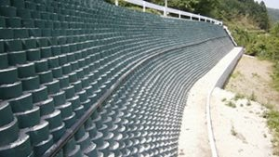  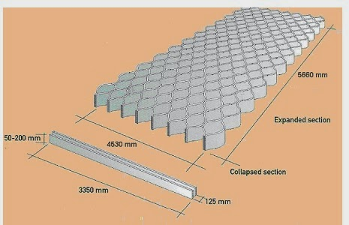
Crib wall | - Material saving  - High stability  - Retaining walls protect slopes for transport works  - Easy to built  - Environmentally friendly  - Low cost | - Build slowly  - Lack of durability since the dead wood materials rots fast. In such construction, when the wooden materials start decaying, the fill materials will start to come out from open spaces under the influence of weathering agents (rainfall, sun, wind, snow etc.) and the whole structure will be collapsed. | 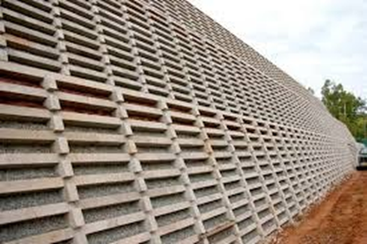
Gabion wall | -Gabions have very high corrosion resistance in the atmosphere because the zinc layer is well bonded on the wire and the ability to support the growth of vegetation.  - Provides automatic and easy drainage without the need to install a drain.  - Resistant to flood force, torrential force and earth pressure. | - Gabions are susceptible to rust by environmental impact  - Build slowly  - Difficult to repair and maintain | 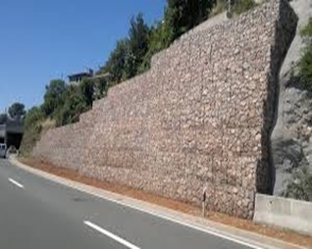  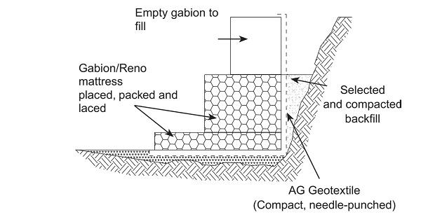
Concrete block wall | - Fast and simple construction and assembly  - Suitable for civil engineering | - Limited height  - Drainage plays an important role | 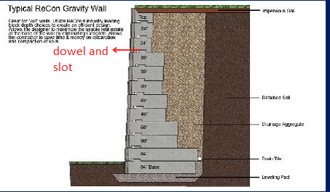
Table1. Types of gravity retaining walls.

Drainage for embankment behind retaining wall.
- Whether the embankment behind the retaining wall is loose or cohesive soil, the water in the embankment will change the physical and mechanical properties of the soil. It endangers the retaining wall because of increased soil pressure and there is an extra hydrostatic pressure.
- Therefore, it is necessary to install a drainage system for retaining walls. The drainage aims for the following two purposes:
- Enable the water accumulated in the pore of the soil to escape quickly or prevent water from seeping into the embankment.
- Prevent water from contacting the back wall to eliminate the water pressure acting on the back wall.
- Water infiltration into the backfill wall may be due to the following factors: rainwater falling, surface water in nearby areas or water infiltrating in other areas.
- In order to drain the backfill soil, a drainage device is usually required. Drainage devices generally consist of the following four parts:
- Part one: surface drainage.
- Part two: reduce the amount of groundwater into the embankment.
- Part three: drainage in embankment blocks.
- Part four: draining water outside of the retaining wall.
Types of drainage equipment can be used with the following characteristics:

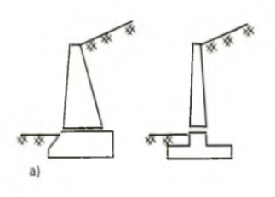  a) Only drainage holes | 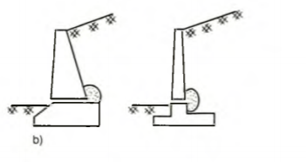  b) Drain holes are arranged with piles
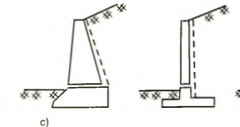  c) Vertical drainage ditch | 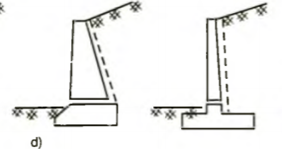  d) Drainage floor close the back wall
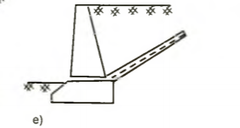
e) Inclined drainage floor (following direction of the sliding surface)
Table 2. Types of drainage equipment

Conditions in use of gravity retaining wall.
- Gravity retaining wall is a popular option for residential area, storm canals or the coast where real estate is limited.
- The normal height of retaining walls is 6m without geogrid reinforcement (Geotechnical composites are used for soil consolidation and similar materials). If the height of retaining wall is over 8m (H>8m), then using reinforced concrete wall or another type of retaining wall to guarantee the project is necessary. The gravity retaining walls would have a height >3 m.

Scope of application.
- Replacing talus slope of embankment of ordinary soil which have low slope to reduce the occupied field area.
- Applying to structures which support the blocks of sliding or erosion on natural slopes where the route exists.
- Implementation for roads leading to the city bridge, river banks and coastlines embankment, upgrading and widening of the road surface to the negative talus roof when limited in area ...
- Creating artificial hills.

Chapter III. Explanation of calculation

The background of calculation.
- The theory of calculating soil pressure is one of the most important and complex issues. To solve this problem, there are many different views on the theory of computation. But there are two main kind:
- The type which does not consider the hardness of the wall and the form which takes into consideration the hardness of the wall.
- The form neglect the rigidity of the wall, assumes that the wall is completely solid and only consider the values of soil pressure in the limit state of active pressure and passive pressure. We can divide it into to group:

Group theoretical equilibrium limit of solid mass.
- Theories in this group assume that the sliding soil mass behind the retaining wall is limited by a sliding surface of a predetermined form, such as a solid in equilibrium. Based on hypothetical sliding surface, this group currently develops in two trends:
- The trend assumes a flat sliding surface: representation has Charles-Augustin de Coulomb (1773), K. Cunman…
- The trend assumes a curves sliding surface: W, Fêlêniut, L, and Rănđulic…

The group according to the limit elemental equilibrium theory (point).
- This theory group advocates calculating the values of active soil pressure and passive soil pressure assuming that the points of the embankment environment reach equilibrium limits at the same time. Representing this theory is Dr. John Rankin and was later developed by a number of researchers and developed in two directions:
  - Analytics direction.
  - Graphic direction: solve limit equilibrium theoretical problems by solving methods using specific circle systems.
  - So far, the theory of soil pressure on soft walls has not been fully studied like the theory of soil pressure on hard walls.

- Calculation and explanation:
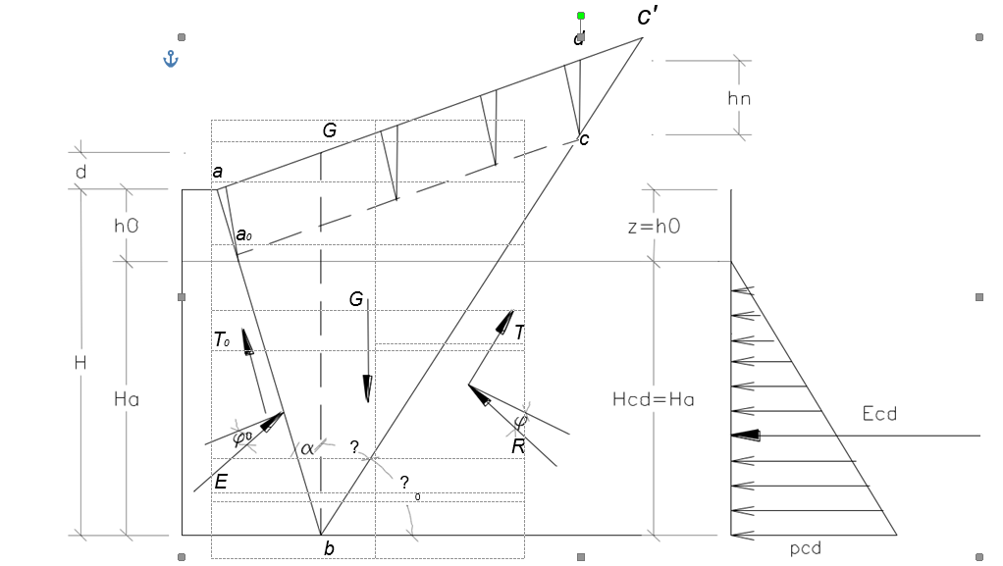

Determine Ecd
E_{cd}= (1)
- Symbols used are as follows:
    - E: The thrust of soil on the wall (T/m)
    - G: The mass of the soild on the wall (T/m)
    - T₀: Adhesion force between wall back and the sliding soil block act on the back of the wall (T/m)
    - T: Cohesion force between the soil mass and the sliding soil mass, acting on the sliding surface (T/m)
    - Θ₀: Sliding angle with horizontal (degree)
    - Θ: Sliding angle with vertical (degree)
    - (Θ₀=90⁰- Θ)
    - α: The inclination angle of the wall back is done with the vertical, (α can be negative, positive or equal 0)
    - β: The inclination angle of the roof is done with the horizontal, (β can be negative, positive or equal 0)
    - ϕ: Internal friction angle of soil (degree)
    - ϕ₀: Friction angle between backfill and back wall (degree)
    - c: Cohesion unit of embankment (T/m2)
    - c₀: Cohesion unit of backfill to wall (T/m2)
    - z₀: Depth of the point has active pressure Pcđ=0 (m)
    - h: The depth of the gap between the embankment and the wall (m)
    - h₀=z₀=
    - h_{n}: The depth of vertical crevices grows in the embankment (m)
    - h_{n} =z_{n} =
    - H: Retaining wall height (m)
    - H_{a}: Height under pressure of retaining wall (m) (H_{a}=H-H₀)
    - A_{0;} B₀: Index of geometric dimensions of embankment blocks:
    - A, B are dimensionless coefficients:
- We have:
    - K₀ = B₀ – D_{n} – D₀ (1- tgα*tgϕ) (2)
    - K₁ = A₀ – B*tgα + D_{n} (tgα+ tgβ + tgϕ- tgα*tgβ*tgϕ) (3)
    - K₂ = - A₀*tgα - D_{n} - D₀ (tgα+ tgϕ) tgβ (4)
    - D_{o}= (5)
    - D_{n}= (6)
    - d=H.tg.tg (7)
    - A₀= $H*\frac{H+d}{2}-\frac{{Hn}^{2}}{2}$ (8)
    - B₀=H*(H+d)*2*tgα/2 (9)
    - A=sin-costg (10)
    - B=cos+sintg (90-0) (11)
    - h_{n} = (12)
    - h₀= (13)
    - G= γ [area (ABC’) - area (CC’D)] (14)
    - T₀=c₀+A₀*B (15)
    - T = c*B*C (16)

Determine the slip surface θ
- The slip surface is determined by the equation: =0
- We have:
    - M1 =
(14)
    - M2 =
(15)
- Solve the equations we choose the positive value of tangθ then determine θ.
- Replacing to the equation of của Ecd we could find the active pressure of the soil on the wall.
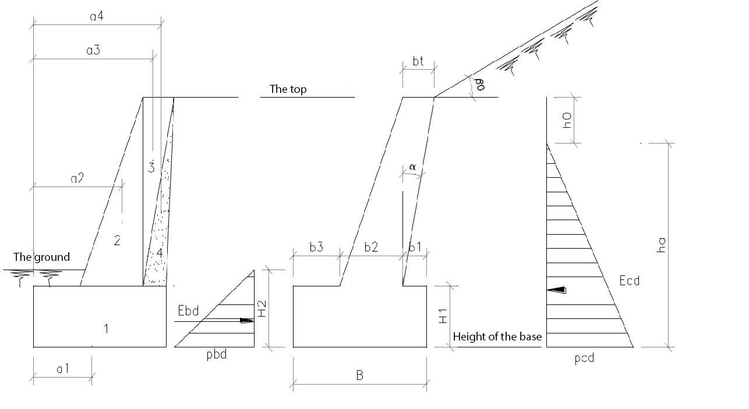
- Select the parameters:
- Height of wall: H
- Width of the foundation: B= (0.35-0.45)*H
- Width of the the top of the wall: bt
- Width of the the bottom of the wall: b2
- Height of foundation: H1
- Width inside the wall: b1
- Width outside the wall: b3
- Grade of concrete :
- Compressive strength Rn: 65 kg/cm²
  - Tensile strength Rk: 6 kg/cm²
  - γ : 2500 kg/cm³

Soil mechanical properties of embankments
- Unit weight: γ₌ 1T/m³
- The cohesion of the soil: C= 1.8 T/m²
- Internal friction angle: ϕ=26º
- W= 39.2%

Vertical soil pressure due to embankment weight
- N=γ*Hb1*B (16)
- Denoted that:
- H: soil layer height (m)
- γ: density of soild (kg/m3)
- b1: width of foundation edges subject to soil load (m)
- B: width of the soil mass along the wall, we choose B=1m

Earth pressure is passive
- Ebd = (H²=1m) (17)
- K_{bd} =
=>> Ebd và hbd
- Flip checking:
- Checking the flipping condition around the edge
- Total momen force of anti-roll forces around the front edge of the retaining wall:
M_{g}= (G_{i}.a_{i}+Ebd*hbd)*0.9 (18)
(G_{i} (kg) is the weight of each block, a_{i} (m) the arm of force)
- Total momen force of pushing forces around the front edge of the retaining wall:
M_{l} = (Ecd*hcd)*1.1 (19)
=>> K_{l}= M_{g}/M_{l} >1.5 (the wall is stable, does not flip)
- Checking eccentric pour condition e < B/6
- Eccentricity dump e=M*N
- Total torque at the center of the foundation:
M=1.1*(€G_{i}*x_{i})-0.9(Ecd*ha)
(x_{i} - the distance from the center of the Gi blocks to the center of the bottom of the retaining wall)
- Total vertical force at the center of the foundation:
N*=0.9*€Gi (20)
- Checking slip flat:
- T_{g}= (E_{bd} + G_{i}*f_{i})*0.9 (21)
- T_{t}= E_{cd}*1.1 (22)
- K=T_{g}/T_{t}> 1.5 (the wall is stable, does not slide)
- Calculation for the retaining wall with different height
- A program was designed for automatic checking the stability of gravity retaining wall, as given in index A.

Calculation for several examples of gravity retaining wall.
- The program was first check with the simple example to ensure the correctly. Then it is used to calculate the main dimension of gravity retaining wall with the different height.
- To calculate we assume:
- No vehicle load, no water pressure of the ground water.
- Horizontal floor surface.
- The inclination angle of the roof is done with the horizontal: β = 45º
- Friction angle between backfill and back wall: ϕ₀ = 15º
- The ground surface is clay sand:
Cohesion unit of embankment: C = 1.8 T/m²
Internal friction angle of soil: ϕ = 26º
  - The retaining wall is made by cobble stone:
γ of cobble stone: 2500 kg/m³

Illustration of calculation examples.
- The main dimension of gravity retaining wall was proposed for different height was listed in Table, while the schema of each wall was drawn as below:
H(m) | b(m) | bt(m) | b1(m) | b2(m) | b3(m) | H1(m) | H2(m) | Check The stability
4.2 | 2.1 | 0.6 | 0.5 | 1.2 | 0.4 | 1.2 | 0.8 | Not ok
4.1 | 2.0 | 0.6 | 0.4 | 1.2 | 0.4 | 1.2 | 0.8 | ok
3.1 | 1.8 | 0.6 | 0.4 | 1.0 | 0.4 | 1.1 | 0.8 | ok
4.2 | 2.1 | 0.6 | 0.4 | 1.2 | 0.5 | 1.2 | 0.8 | Not ok
3.1 | 1.8 | 0.6 | 0.4 | 1.0 | 0.4 | 1.1 | 0.8 | ok
4.1 | 2.0 | 0.6 | 0.4 | 1.2 | 0.4 | 1.1 | 0.8 | ok
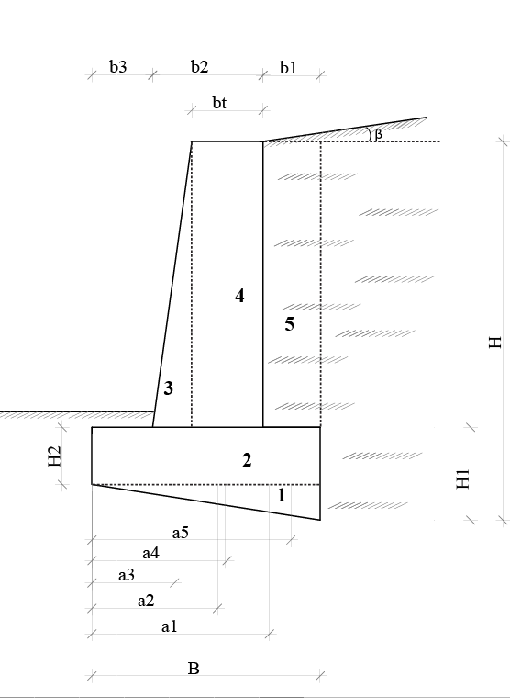
Table 3. The front body is tilted, the posterior body is straight.
H(m) | b(m) | bt(m) | b1(m) | b2(m) | b3(m) | b4(m) | H1(m) | H2(m) | Check The stability
5.3 | 2.7 | 0.6 | 0.5 | 0.9 | 0.8 | 0.5 | 1.3 | 0.8 | Not ok
6.4 | 3.5 | 0.6 | 0.6 | 1.2 | 1.0 | 0.7 | 1.4 | 0.8 | Not ok
7.6 | 4.2 | 0.6 | 0.8 | 1.5 | 1.1 | 0.8 | 1.6 | 0.8 | Not ok
3.1 | 1.8 | 0.6 | 0.4 | 0.6 | 0.4 | 0.4 | 1.1 | 0.8 | Ok
5.3 | 2.8 | 0.6 | 0.6 | 1.0 | 0.7 | 0.5 | 1.3 | 0.8 | Not ok
6.4 | 3.4 | 0.6 | 0.6 | 1.2 | 1.0 | 0.6 | 1.4 | 0.8 | Not ok
7.6 | 4.2 | 0.6 | 0.8 | 1.5 | 1.2 | 0.7 | 1.6 | 0.8 | Not ok
6.5 | 3.6 | 0.6 | 0.8 | 1.3 | 0.9 | 0.6 | 1.5 | 0.8 | Not ok
7.6 | 4.2 | 0.6 | 0.8 | 1.6 | 1.1 | 0.7 | 1.6 | 0.8 | Not ok
5.3 | 2.7 | 0.6 | 0.4 | 1.0 | 0.8 | 0.5 | 1.3 | 0.8 | Not ok
6.4 | 3.4 | 0.6 | 0.4 | 1.5 | 0.9 | 0.6 | 1.4 | 0.8 | Not ok

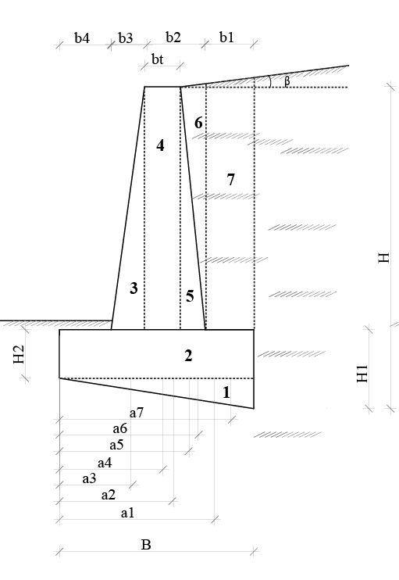
Table 4. Both front and posterior bodies are inclined.
H(m) | b(m) | bt(m) | b1(m) | b2(m) | b3(m) | H1(m) | H2(m) | Check The stability
2.0 | 1.8 | 0.6 | 0.4 | 0.8 | 0.6 | 1.0 | 0.8 | Not ok
3.1 | 2.2 | 0.6 | 0.6 | 1.0 | 0.6 | 1.1 | 0.8 | ok
4.3 | 3.0 | 0.6 | 0.6 | 1.6 | 0.8 | 1.3 | 0.8 | Not ok
5.4 | 3.8 | 0.6 | 0.6 | 2.3 | 0.9 | 1.4 | 0.8 | Not ok
6.6 | 4.6 | 0.6 | 0.7 | 2.9 | 1.0 | 1.6 | 0.8 | Not ok
5.3 | 3.2 | 0.6 | 0.4 | 1.9 | 0.9 | 1.3 | 0.8 | Not ok
6.5 | 4.1 | 0.6 | 0.8 | 2.3 | 1.0 | 1.5 | 0.8 | Not ok
4.2 | 2.5 | 0.6 | 0.4 | 1.5 | 0.6 | 1.2 | 0.8 | Not ok
5.4 | 3.3 | 0.6 | 0.5 | 1.9 | 0.9 | 1.4 | 0.8 | Not ok
4.1 | 2.5 | 0.6 | 0.4 | 1.5 | 0.6 | 1.1 | 0.8 | Not ok
5.2 | 2.9 | 0.6 | 0.4 | 1.8 | 0.7 | 1.2 | 0.8 | Not ok
3.0 | 2.0 | 0.6 | 0.4 | 1.0 | 0.6 | 1.0 | 0.8 | ok
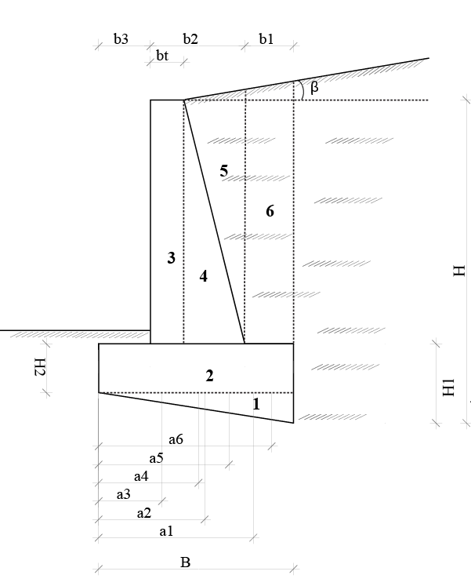
Table 5. The front body is straight, the posterior body is inclined.

Chapter IV: Conclusions and recommendations.
In this study, the using of gravity retaining walls to stabilize embankments or digging out of landslides were investigated. The types of gravity retaining wall, along with the advantages and disadvantages of each were observed. Gravity retaining wall is a simple retaining wall that is easy to execute, saving construction costs, so it is commonly used in Vietnam
The topic "Study on the stability of highway slope using gravity retaining wall " has just stopped again at the level of earth active pressure, earth passive pressure, the ground is horizontal, the back wall is straight or incline, the wall is reinforced concrete wall. When strongly affected by hydrodynamic pressure and underground erosion or inclined ground, the load on the ground (concentrated or triangular load or trapezoidal load) will not apply the results of this thesis, need to continue going in depth and developing to apply diversity to reality.
From the calculation table we conclude that for the embankment case as above, the retaining wall will be stable at a height of 3-4m.
We recommend the use of inclined in front and straight back walls to apply in construction. To optimize to save costs as well as installation and transportation, we should use retaining walls with a height of 3-4m. For taller walls, to increase stability, we recommended to use concrete, reinforcing wall.
Future research directions:
- Auditing with more complex cases, including vehicle load, humidity conditions, different tightness of the roadbed.
- Research other types of retaining walls such as thin wing walls, gabions, ...
- Research other methods of slope protection such as using anchors combine with reinforced concrete frames; reinforced walls ...

References
- TCVN 2737: 1995 Actual load - Design standard.
- TCXD 45-78: Design standards of houses and buildings.
- TCVN 9152: 2012: Irrigation works - The process of designing retaining walls for irrigation works.
- TCXDVN 57:1973: Designing retaining walls for hydraulic works.
Soil pressure and retaining wall - Publisher Xây dựng – GS. Phan Trường Phiệt.
Soil Mechanics Book - Publisher Xây dựng – Vũ Công Ngữ – Nguyễn Văn Thông.
- Các tài liệu từ nguồn intenet:
Workshop on retaining walls (https://123doc.net/document/2304282-hoi-thao-chuyen-de-ap-luc-dat-thiet-ke-tuong-chan-dat.htm)
https://link.springer.com/article/10.1007/s10706-017-0342-5
https://www.geotech.hr/en/gabion-walls/
https://theconstructor.org/geotechnical/retaining-wall-types-use/24566/?fbclid=IwAR3WCgcC2rrMpP7O-W4LqhhzMbkwSZBmb1JmKJNvN7CE9u-jCSyVy4kbZOc

